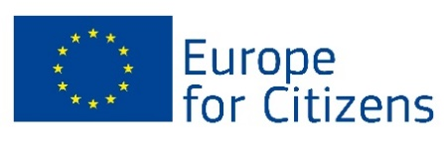
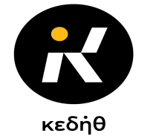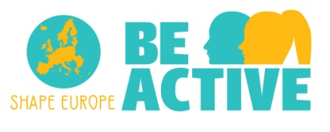
___________________________________________________________________________
Community Enterprise of the Municipality of Thessaloniki
164, K. Karamanli
542 48, Thessaloniki
T. 2311 821722
Information: Dimitris Georgiadis,
Argiro Skitsa
E-mail: georgiadis@kedith.gr

Thessaloniki, 03/05/2019

INVITATION
“

Be Active -Shape Europe Project
KICK OFF EVENT
You are cordially invited to participate on the Kick off event and 1st Structured Dialogue organized by the Community Enterprise of Thessaloniki as part of the Be Active – Shape Europe program, funded by the Europe for Citizens Program,
on the 6th of May 2019
at the premises of the Youth Information Office of the General Secretariat for Lifelong Learning and Youth in the Port of Thessaloniki.
The agenda to the event is as follows:
Agenda of the Kick off Meeting/ 1st Structured Dialogue
10.00- 11.30 Ice breaking Games- Brainstorming session: active Youth participation, democratic engagement and its importance to the quality of Democracy and our european way of living
11.30- 13.00 Discussion of EU elections: What do we know about the process and why is it important to participate?
13.00- 13.30 Coffee break and networking
13.30- 14.00 Reflection, Proposals and Information of the next activites to the Be Active- Shape Europe project.
A certificate of attendance will be given to all participants!
We remain at your disposal for any further query or information.

